## Product Description

* Development board model: ESP32-DevKitC-32
* Module model: ESP32-WROOM-32
* Main control chip: ESP32-DOWDQ6-V3 dual-core 32bit MCU integrated WiFi, Bluetooth,
* Integrated 520-kBSRAM, 448-kBROM16-kBSRAMinRTC
* External storage: 4MB
* USB driver chip: CH340C, with good system compatibility, higher download speed, and more stability.
* Support VIN external wide voltage input 5-12V power supply (battery version maximum 5.5V input)
* Support USB power supply, external 3.3V power supply, and VIN power supply three kinds of power supply Mode development
* board size: 52*28mm
* weight about 9.5g
* Compatible with ArduinoIDE mixly, mind+, Python and other programming software

 Package: 2 PCS ESP32 Type-C USB Development Board

              2pcs  Expansion Board

## Product information

### Technical Details

|  |  |
| --- | --- |
| Wireless Type | ‎Bluetooth |

|  |  |
| --- | --- |
| Brand | ‎AITRIP |
| Item Weight | ‎2.15 ounces |
| Package Dimensions | ‎5.71 x 4.21 x 1.26 inches |
| Color | ‎2SET ESP32-CH340C-TYPE C |
| Processor Count | ‎2 |
| Manufacturer | ‎AITRIP |
| ASIN | ‎B0B82BBKCY |
| Country of Origin | ‎China |
| Date First Available | ‎July 29, 2022 |

## About powering the ESP32

[ESP32 Pinout Reference - Last Minute Engineers](https://lastminuteengineers.com/esp32-pinout-reference/#:~:text=There%20are%20two%20power%20pins,an%20on%2Dboard%20voltage%20regulator.)

This site contains very useful information about the pins and how/when (not) to use them.

### Power Pins

### There are two power pins viz. VIN pin & 3.3V pin. The VIN pin can be used to directly supply the ESP32 and its peripherals, if you have a regulated 5V voltage source. The 3.3V pin is the output of an on-board voltage regulator. This pin can be used to supply power to external components. GND is a ground pin of ESP32 development board.

## On-board Voltage regulator

The WROOM board I have has a 1117-33 voltage regulator. This seems to be capable of handling 5V input and regulates it to 3.3V for the ESP32 chip. See [1117 33 | PDF | Physical Quantities | Computer Engineering](https://www.scribd.com/document/338520994/1117-33)

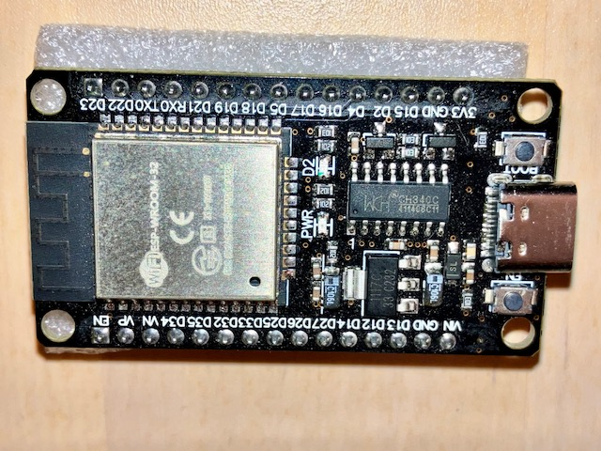

### **Configure IDE**

In the Arduino IDE you must install esp32 environment, refer to “[ESP32: pinout, specs and Arduino IDE configuration](https://www.mischianti.org/2020/05/30/esp32-pinout-specs-and-arduino-ide-configuration-part-1/)“, then you must configure the correct board information, now I use an esp32-wroom-32 and I set:

* **Board**: ESP32 Dev Module
* **Flash Frequency**: 40MHz
* **Upload Speed**: 921600 (115200 is more secure)
* **CPU Frequency**: 240 MHz
* **Flash Size**: 4MB